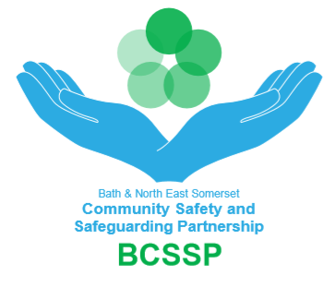

Appendix A
B&NES Community Safety & Safeguarding Partnership (BCSSP) Multi-Agency Protocol for resolving and escalating professional differences of opinion regarding safeguarding decisions - Resolving Professional Disagreement Recording Pro-forma

This form is to be used to register use of the Protocol for any professional disagreements beyond level 1.

Please send securely for the attention of the BCSSP Business Support Manager to:
- BCSSP@BATHNES.GOV.UK
Please password protect if not being sent from a secure B&NES Council, Virgin Care, Sirona care and health, nhs.net, pnn.police.uk, cjsm.net, gsi.gov.uk email address.

For all Health commissioned services, the Business Support Manager will securely send a copy to the Designated Nurse CCG, who will disseminate to relevant Safeguarding Lead in Health in order they can keep an audit of use of escalation policy in their organisation.

Case Details Date of Original Escalation:

Child’s/Adult’s Name:

Address:

Agencies/ Workers involved
Names | Designation | Agency | Contact Details

Nature of Professional Disagreement
Attempts to resolve issue
Unresolved Dispute and Referral to BCSSP Chair (BCSSP Staff Only)

Date of Referral:

Chair’s Decision to Convene a Resolution Panel:
Outcome and Date of BCSSP Resolution Panel
July 2020

