**Children’s Social Care**

**Redesign of Safeguarding Outcomes Service Area**

**July 2020**

Children’s Social Care have successfully completed the re-design of their Safeguarding Outcomes Service. Following a lengthy consultation in 2019-2020, the new service model was implemented with effect on June 29th, 2020. The aim of the redesign is to improve services and outcomes for children and young people in B&NES.

The re-design was supported by the **Improving How We Work project- IHWW** a group of colleagues including experts in Service Design, IT, data management, HR and external consultancy services, working closely with Children’s Services.

The redesign has involved some structural and practice changes to how social work services are delivered. These include:

* Moving from a rotating Duty team to a non-case holding static **Triage** team
* The establishment of a **‘Hub’ system of ‘Family Support’ teams**, as soon as it is felt that Social Care support is required for a family, whereby practitioners work in a relationship-based and strengths-based way, underpinned by a ‘Systemic’ methodology
* The establishment of a **Family Support Plus** team that centralises a range of specialism into one team
* Underpinned by **Systemic Practice, which** is a way of working which emphasises people’s relationships as key to understanding their experiences. Understanding the complex context of families can help people to change patterns of thinking

The overall **ambition** of these changes are:

1. More children and young people will be effectively safeguarded in their family
2. An increased reported satisfaction from families about the service they are receiving from Social Care
3. Fewer children being permanently removed from their family and friends network
4. An increased reported satisfaction from multi-agency partners about the service they are receiving from Social Care
5. A reduction in the number of ‘re-referrals’ of children to Social Care
6. An improved retention of staff in these new teams alongside increased job satisfaction

2. Drivers for Change

Team Design (Structure Chart

**Detailed Functions of New Structure**

1. **Triage Team - structures and functioning**

In this new design, the Duty and Assessment Team becomes a static non-case holding triage team. The principle behind the Triage Team is that they are not case holding but instead receive requests for service that have been through the electronic ‘landing page’ (another alpha project that the IHWW team has led on), from professionals and members of the public.

There are 3 Referral and Information Assistants (known as RIOs), who will look at all contacts and along with the senior staff in the Triage Team (Team Manager, Deputy Team Manager and Senior Practitioners) decide if further enquiries are needed. Contacts will be triaged to ensure that families are receiving the right support, from the right service in a timely way. The Social Workers will make enquiries of professionals and through conversation, determine the appropriate level of support needed for the family. They will have greater opportunities for developing close, supportive connections with our referrers and partners

The relationships that the Triage Team will be able to develop with partner agencies are likely to gain strength as they will be the same group of staff consistently engaging with referrers. These relationships will be crucial, so that honest and open conversations can take place about the needs of families being referred.

The Triage Team will also work dynamically with referrers; it is anticipated that they will, where needed, proactively visit schools to supportively challenge key referrers to think about their analysis and actions.

The staff in this team will be able to shape and develop the key intersection with other professionals and their values and relationship-based way of working will still be integral. There is the potential for workers in this team to work closely with, supporting and advising, Early Help colleagues within Team Around the Family meetings for example, and with Early Help Assessments, where social care involvement is deemed to be not required.

1. **Family Support and Child Protection Hub teams - structures and functioning**

It is envisaged that once enquiries have been made, and the decision is taken that a social care input is necessary, the family will be opened immediately to one of the 6 Family Support Hubs. The 6 Hubs would be on rotation in terms of who would be ‘picking up’ new work, provisionally on a weekly basis.

In this revised model, Family Support Practitioners (FSP’s) become part of the Hubs and will bring their experience to bear on the decision-making and exploration around family difficulties, with a reduction in the ‘handover’ or ‘referring out’ for families. The FSPs will become an integral part of the team, contributing from their unique and valuable perspective to the discussions around families. This will lead to more cohesive and consistent work with families.

1. **Family Support Plus Team**

We are extremely fortunate and proud to have developed additional “specialist services” in B&NES. These services have now been brought into one team as a shared resource across the service and will bring an added value to the social work service that we provide to families. These services include:

* **New Way** Service that supports families experiencing Domestic abuse.
* **Stepping Stones** is a group that supports parents experiencing poor mental health: there is also a smaller group that supports the children of these parents with issues around living with a parent or carer with poor mental health. This is a joined initiative between Children ‘s Social Care and AWP
* **Family Group Conferences** is a service that we provide for families to work with close and extended family members to empower them to produce their own family plans to address any issues that they family may be experiencing.
* **Parenting Support Workers** work with families using evidence-informed programmes to support parents who are struggling with some of the key parenting tasks. They work closely with colleagues across the service and provide relationship-based approaches that focus on the challenges that parents might be facing with regards the presenting behaviour of their children, unpicking targeted ways of responding that is evidence-informed.
* **Footprints** is a small virtual team that works with men and women who have experienced, or are at risk of, repeated pregnancies that result in children needing to be removed from their care. We aim to give parents the opportunity to take control of their lives breaking a destructive cycle that causes both them and their children deep trauma.
* **Community Based Assessors** undertake a thorough assessment of parents and children to make sense of how best to support the family and offer support to the parents and children that will most likely improve the chances of them being able to make positive changes.

**Evaluation**

Work will be undertaken with the Business Intelligence Team to build measures so that the impact of any changes can be evaluated. This will be regularly reviewed through redesign steering groups.

**Appendix 1- Safeguarding Outcomes Service**



|  |  |  |  |  |
| --- | --- | --- | --- | --- |
| **Head of Service -Leigh Zywek** | | | | |
| **Team Manager** | **Team Manager** | **Team Manager** | **Team Manager** | **Deputy Team Manager** |
| **Triage Team** | **Child Protection and Family Support 1** | **Child Protection and Family Support 2** | **Child Protection and Family Support 3** | **Family Support Plus** |
| Louise Taffinder  01225 395076 | Liz O’Gorman  01225 396136 | Phoebe Holland  01225 396907 | Sarah Riley  01225 394451 | Freyja Baber  01225 396961 |

**The re-design is also supported by a Practice Framework, this is attached as Appendix 2.**

**‘*Strengthening Our Practice; Supporting Systems’***

**Bath and North East Somerset (B&NES)**

**Children’s Services Practice Framework**

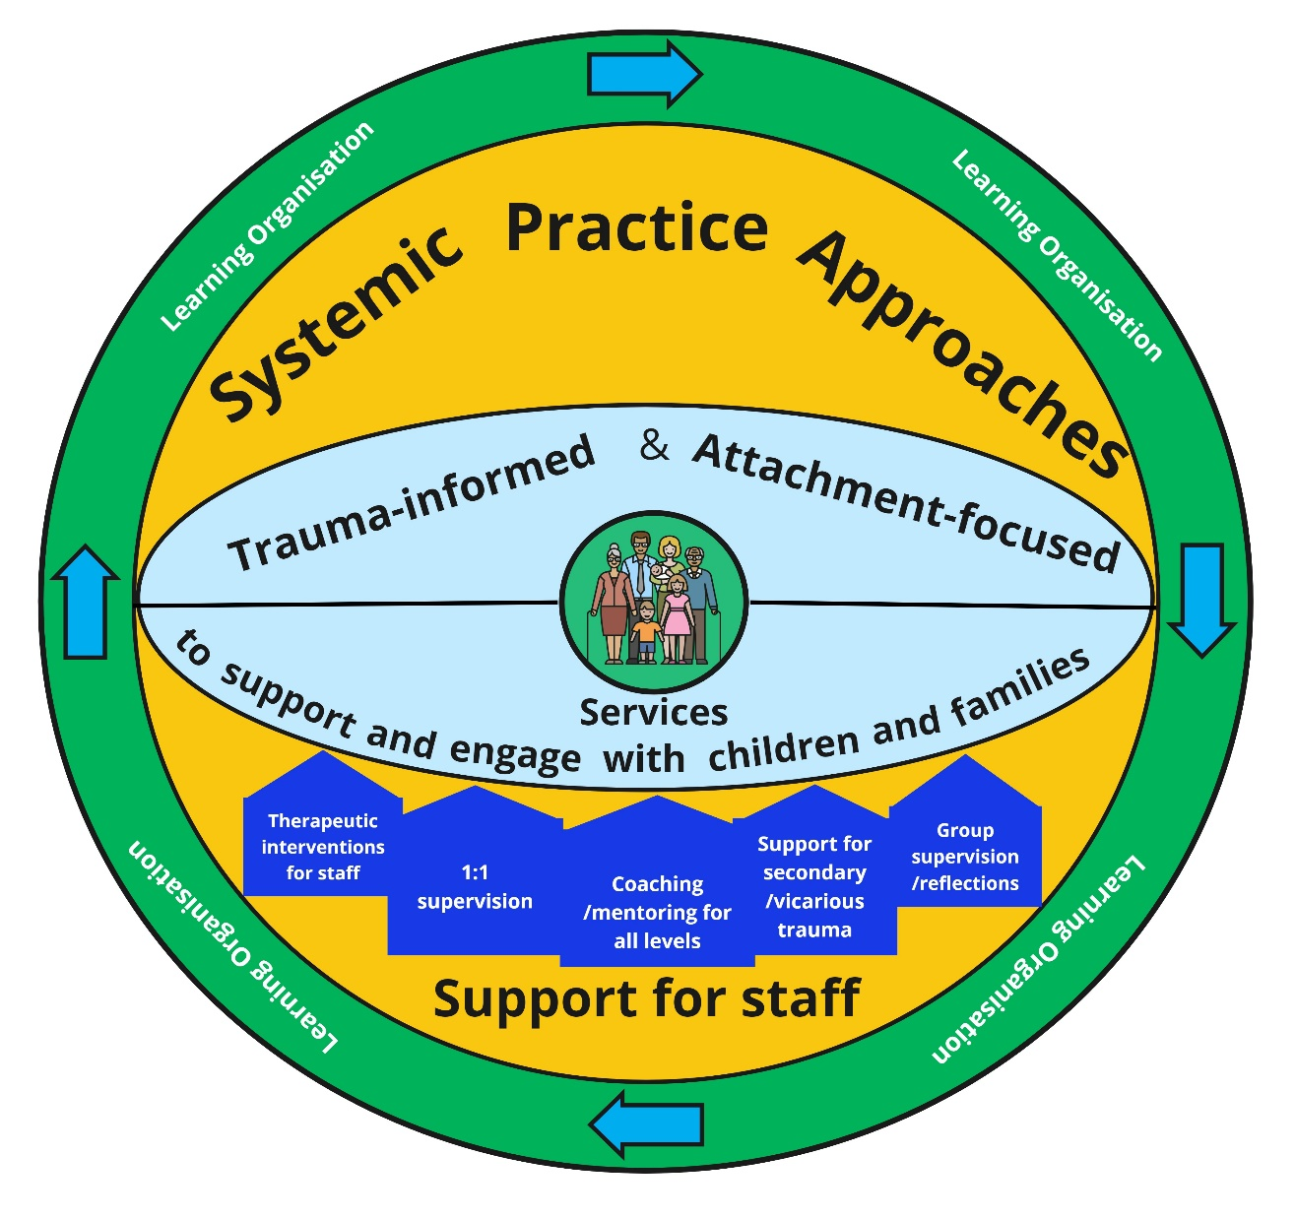

**Bath & North-East Somerset Vision**

The vision for B&NES is that “all children and young people in Bath and North East Somerset will enjoy childhood and be well prepared for adult life” Children and Young People Plan (CYPP) 2018-2021.

There are three key priorities for the council, which children’s services will also work towards [NB these priorities are under review and may change in future:

1. Protecting and caring for our most vulnerable
2. Nurturing residents’ health, safety and wellbeing
3. Providing ways for everyone in the community to reach their potential.

The local authority has recently reviewed and, following engagement and consultation, agreed our six shared values (see BANES council’s “Changing Together” proposals: <https://www.bathnes.gov.uk/changingtogether>)



**Children’s Services Vision**

Our ambition is that we will have a skilled and competent workforce who support and enable families to best meet their children’s needs safely. Where children remain living with their family, connected to their wider community, being given opportunities to grow and achieve.

**Background**

*Why do we need a Practice Framework?*

We recognise that as a public service and in our role within the local authority, we need to ensure our approach to working with children and their families is clear and meaningful; for our colleagues, service users, and the wider public. We are trying to develop consistency around what our work with families will be based on, with a shared language and shared understanding. This will be an ongoing change journey, trying to provide the best possible service and improved outcomes for children, but the change starts with this outline of how we intend to protect and support the children in our community.

Staff tell us that there is no clear shared philosophy for how we should undertake our work, and that in comparison with a number of other Local Authorities in the country, there is no overarching guide to how they should work – i.e. there is no ‘B&NES model’.

This framework is to be finalised after consultation with staff, partner agencies and children/families. An all-staff workshop in November 2018 considered different practice theories and models; this was followed by a further senior manager workshop in February 2019 to build on the principles that B&NES has developed over the last few years, following which a Practice Principles document was drafted. The document has now been shared with Managers and the wider social care workforce, and it is anticipated that this will also be shared with wider agency partners and families in the near future.

**Our 9 Practice Principles**

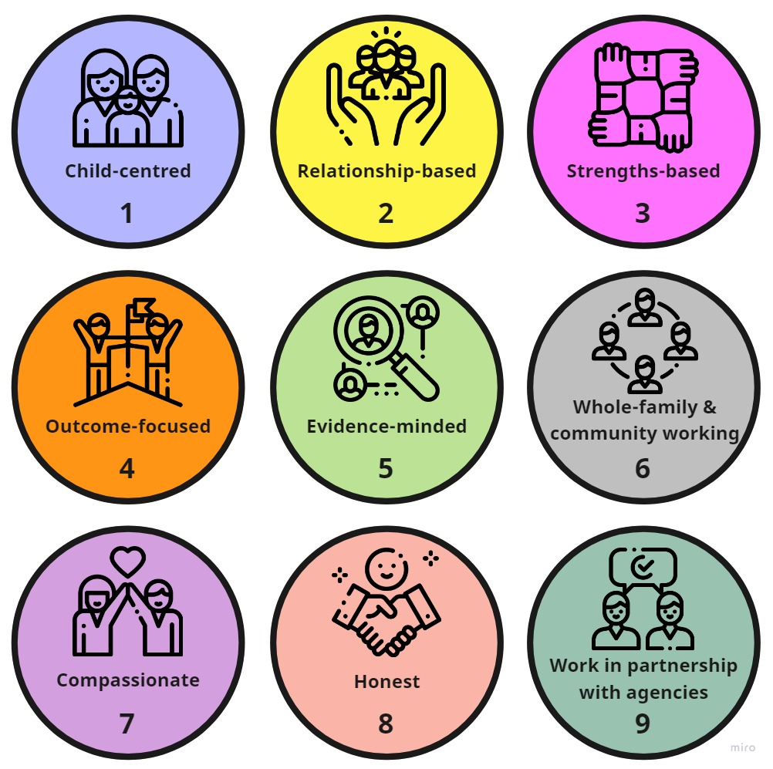

1. **Child-centred:** We keep taking the time to listen to children and young people and hear what they are trying to tell us, however this might be done, whether through words, behaviours or non-verbal communication. Their voices and their wishes are at the heart of what we do. How we respond to children, with kindness, compassion and care, is central to our work and their wellbeing.
2. **Relationship-based:** We aim to work *with* people, not do things to and/or for them. We do this to try and make the most positive and sustainable difference to the lives of children, young people, their families and their community. Developing relationships, based on empathic, compassionate challenge, creates lasting change and is key to our work. We work collaboratively with families and their networks, recognising their strengths as a foundation for taking the risks of change.
3. **Strengths-based:** We recognise that even at the most challenging of times, everyone has strengths on which to build, in themselves and/or within their relationships and networks. We will base what we do on the strengths and resources of individuals as well as their family, alongside their wider social and community network. We value that people are experts in their own lives and we will try to work alongside people to help them and continue to do this as much as possible when we have to make decisions people sometimes don’t agree with. Even at the hardest times we will maintain respect, trying to focus on strengths and positivity.
4. **Outcome-focused:** We will ask ourselves, am I making a positive difference in the lives of this child and their family? Being clear with families about what it is we want to achieve alongside them helps guide our approach, by keeping children safe and promoting their wellbeing. We will aim to help children to be happier, more resilient, safer and achieving more because of our involvement. Sometimes we will have to think carefully about whether we are looking for short term goals or long-term outcomes.
5. **Evidence-minded:** We will ask ourselves, how do I know I am making a positive difference in the life of this child and their family? We will remember that the impact of what we are doing might not be immediate. We will work across the whole system to try and make sure our services and our individual workers are all involved with families in a way that research evidence informs us is right, alongside the professional expertise and views of service users to guide what we do. We will aspire to strengthen our culture to continuously learn and improve, whether that be from everyday conversations, formal participation groups, or large research studies. As things change with families and children, we may need to be adaptable; we will check ourselves and ask if we are still making a difference.
6. **Whole-family and community working:** We place families at the heart of what we do. We will work with families, recognise their place within their wider communities and connect them to the right support. We will engage with, challenge and support families to care for their children safely as far as possible. We will aim to provide families with the right help, at the right time, in the right place. We will be relentless in our efforts to help individuals and families develop safe, supportive connections and increase resilience. We will aim to empower individuals and families to think about the whole lifespan of their children, attempting to *make*, not *break* positive, supportive, healthy relationships to help them come together and cope during the hard times and celebrate and be happy during the good times.
7. **Compassionate:** We will work with people from a basis of understanding that all of us have unique histories. Working with individuals requires us to listen carefully, whilst trying to understand, empathise, and act with kindness and care. It will be important we are curious and do not jump to conclusions. We will keep at the heart of our practice the knowledge of how past traumas can influence the present. We will work with children, adults and their wider networks and communities to put current situations into their appropriate wider context, seeing the individual as a whole, rounded person.
8. **Honest:** We will strive to practice a culture of openness, accountability and trust. We will be transparent and fair, self-critical and reflective, realistic and ambitious.
9. **Work in partnership with other agencies:** We will work closely with other organisations and systems to protect and support children. We will communicate clearly and listen carefully. If it is safe and legal to do so, we will share information and will try not to work in isolation. Good, supportive relationships with colleagues where we can challenge each other - in a spirit of cooperation - will remain important to ensure we are flexible, open-minded and directing our time and energy in the right way.

**Leigh Zywek, Head of Safeguarding Outcomes**

**Mary Kearney, Director Children and Young People Service**

**Mike Bowden, Corporate Director**

**July 2020**